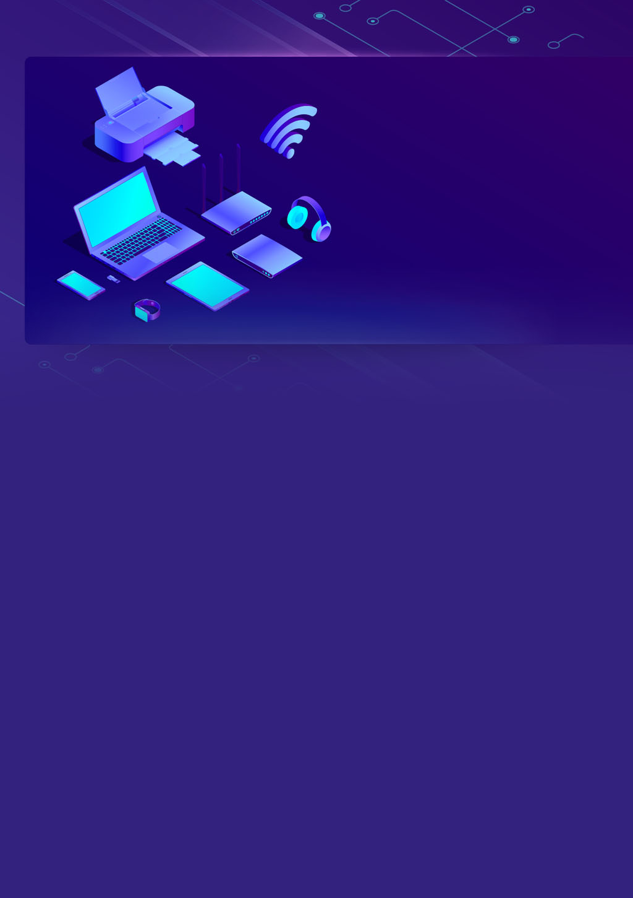

**Assignment**

**Recap**

**IOT internship**

**Team Members: -**

**TL: Mahmoud Essam Fathy: 20221460231**

**Ziad Ashraf Hafez Gaber: 20221374025**

**Ziad Ashraf Ibrahim Taher: 20221369225**



**Assignment – Recap – Problem 1**

**Description**

**Of the code**

**This project is a security system that uses an ESP32 microcontroller.**

**It has a keypad for password input, a servo motor for a door lock, an LCD display, an LDR for light sensing, and an IR sensor for object detection.**

**Authorized users can enter a password to unlock the door, and the system displays sensor readings inside.**

**Keypad: Four row pins (13, 12, 14, 27) and four column pins (26, 25, 33, 32) connect the keypad to the ESP32.**

**Servo Motor: The servo motor connects to pin 23 of the ESP32 to control the door lock.**

**LCD Display: The LCD display uses pins RS (22), E (21), D4 (19), D5 (18), D6 (5), and D7 (4) to connect to the ESP32.**

**LDR (Light Dependent Resistor): The LDR connects to pin 34 of the ESP32 to measure ambient light levels.**

**IR (Infrared) Sensor: The IR sensor connects to pin 35 of the ESP32 to detect objects in front of it.**

**ESP32 Microcontroller: Main control unit that handles input, controls the servo motor, reads sensor values, and displays information.**

**Keypad: Enables users to enter the password for unlocking the door.**

**Servo Motor: Controls the door lock by opening and closing the door.**

**LCD Display: Shows messages and sensor readings for user feedback.**

**LDR (Light Dependent Resistor): Measures ambient light levels for adjusting lighting conditions.**

**IR (Infrared) Sensor: Detects objects in front of it, helping to ensure security and trigger actions.**

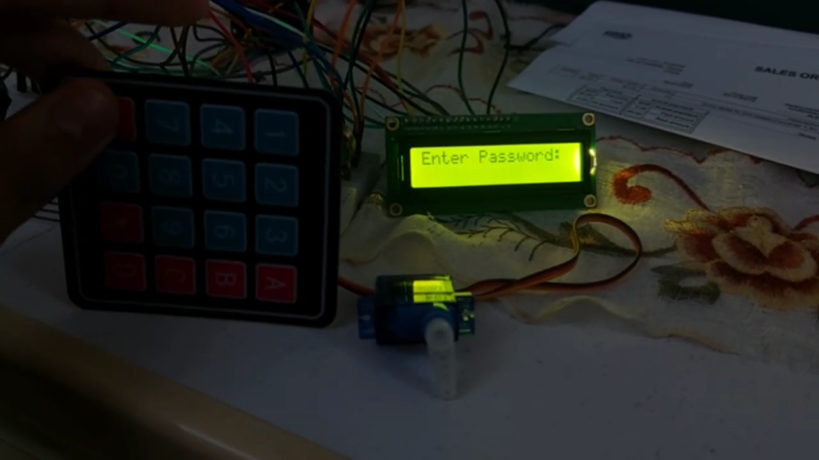

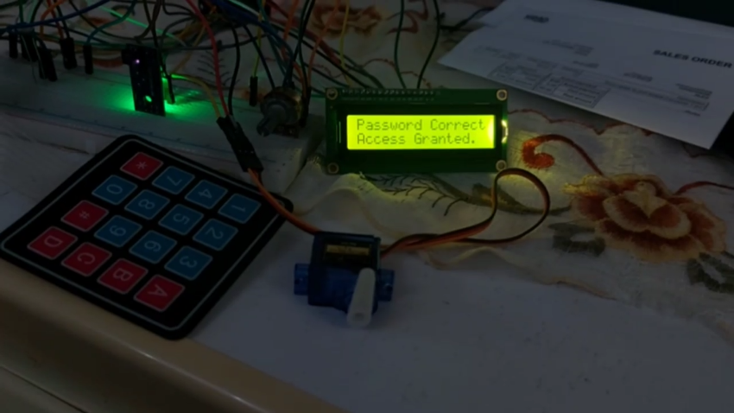



**Assignment – Recap – Problem 2**

**Description**

**Of the code**



**Assignment – Recap – Problem 3 Bonus (everything)**

**Description**

**Of the code**

**This code is for an ESP32-based project that uses various components to achieve different functions:**

**Components and Functions:**

**LCD Display: Shows information on a screen.**

**Buzzer: Can make sounds.**

**IR Sensor: Detects objects/movement.**

**LED: Lights up based on light levels.**

**Button: Used to choose different functions.**

**Photoresistor: Measures light.**

**Servo Motor: Moves back and forth.**

**Keypad: Used for input.**

**Modes and What They Do**

**Read and Display Sensors: Shows IR and light readings on the LCD. Turns on the LED in low light.**

**Servo Scanning: Moves the servo motor back and forth, showing the angle on the LCD.**

**Password Entry: Lets you type a 4-digit password on the keypad. Displays * for each digit. Unlocks servo if password is right.**

**Smart Door: Uses IR sensor to open the servo motor and unlock the door if something is close. Locks if nothing's detected.**

**The program keeps checking for input and performs actions based on the selected mode. It helps navigate using the keypad and displays feedback on the LCD. The code might need adjustments for practical us**

**“Video and Real life And Breadboard supported in folder”**

